**Database Connectivity in Python – STEPS**

1. Install pyodbc using the command <pip install pyodbc> without angle brackets.
2. Connect to SQL Server using the python script.

import pandas as pd

import pyodbc

conn = pyodbc.connect(

    'Driver={SQL Server};'

    'Server=DESKTOP-VOT1DO6\MSSQLSERVER_NEW;'

    'Database=HelloWorld;'

    'Trusted_Connection=yes;'

)

cursor = conn.cursor()

**Create a new record – STEPS**

cursor.execute(

    "INSERT INTO Employee_personal_new \

    (EMPID,NAME,PLACE,GENDER,AVAILABLE,PHNO,DEPARTMENT) \

    VALUES (9, 'Keneil', 'Paris', 'Male', 'NO', '876', 'Comp')"

)

conn.commit()

print("\n")

data_frame = pd.read_sql_query('SELECT * FROM Employee_personal_new', conn)

print(data_frame)

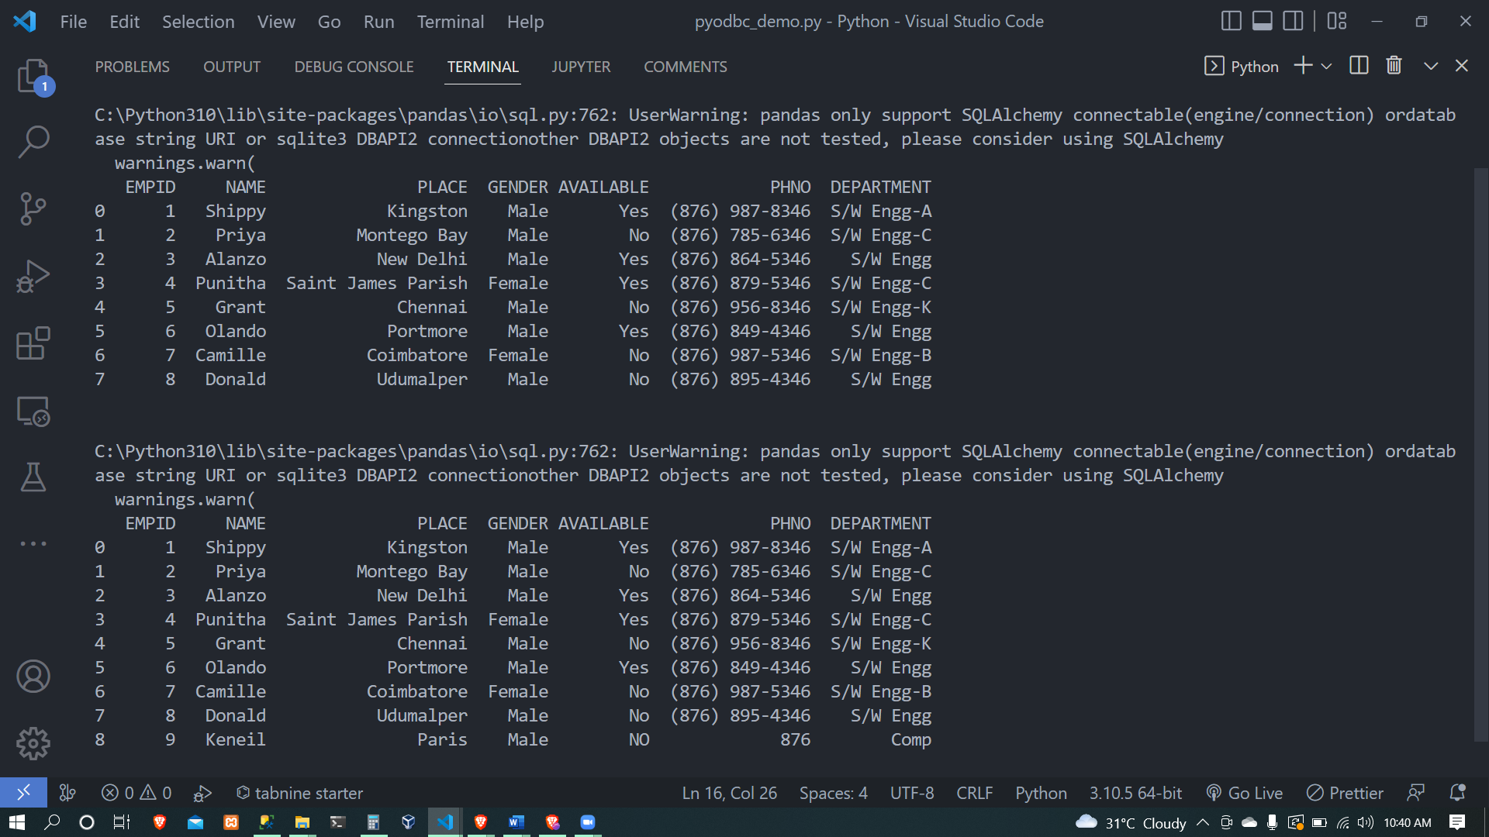

**Update an existing record – STEPS**

cursor.execute(

    "UPDATE Employee_personal_new \

    SET NAME = 'Keneil Update' WHERE EMPID = 9"

)

conn.commit()

print("\n")

df = pd.read_sql_query('SELECT * FROM Employee_personal_new', conn)

print(df)

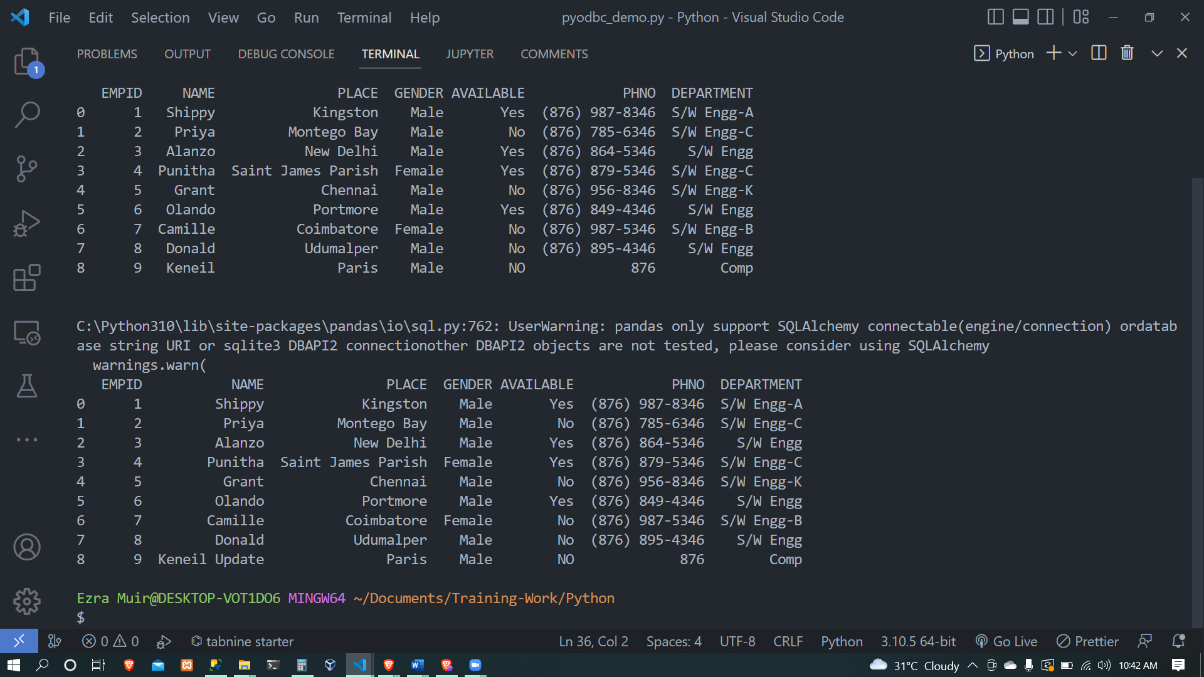

**Delete an existing record – STEPS**

cursor.execute("DELETE FROM Employee_personal_new WHERE EMPID = 9")

conn.commit()

print("\n")

df1 = pd.read_sql_query('SELECT * FROM Employee_personal_new', conn)

print(df1)

